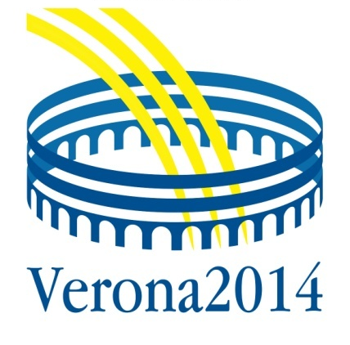 | European Workshop on  Skin immune mediated inflammatory diseases (Simid)  Verona, Italy  24-26 April 2014

The rapid growth in the understanding of the molecular mechanisms of skin immunology, inflammatory cutaneous diseases and skin manifestations of extracutaneous disease deserves special attention. Old inflammatory skin diseases are receiving new interpretations based on the advancements on the molecular bases of innate immune responses. Common pathways in diseases affecting different organs are being elucidated. Many new treatment options are becoming available, increasing the need of forums where basic, translational and clinical research are presented together. Inflammatory and immune-mediated diseases have a great relevance to general medicine and other internal medicine disciplines, providing clues for understanding pathogenesis, as well as for diagnosis and therapy. Successful propagation of knowledge is essential to translate science and medical progress into improved patient care.

Chairman:  Giampiero Girolomoni, Verona  Scientific secretariat:  Paolo Gisondi, Verona | Scientific committee:  H. Bachelez, Paris  S. Beissert, Dresden  L. French, Zurich  C. Griffiths, Manchester  G. Jemec, Roskilde  L. Puig, Barcelona  F. Rongioletti, Genoa  P. van de Kerkhof, Nijmegen

Sessions:
- Workshops
- Lectures
- Free communication sessions
- Posters

Topics:
- Lupus erythematosus  - Scleroderma  - Sclerodermoid disorders  - Vasculitis syndromes  - Occlusive vasculopathies  - Autoinflammatory syndromes  - Syndromes from innate immunity dysregulation  (eg, hidradenitis suppurativa, pustular psoriasis)  - Neutrophilic dermatoses  - Psoriasis | - Cardio-metabolic risk of chronic inflammation  - Common pathways in organ-specific inflammatory disorders  - Febrile dermatoses  - Psoriatic arthritis  - Rash and arthritis  - Autoimmune bullous diseases  - Eosinophilic dermatoses  - Drug reactions  - Stratified medicine

www.simid2014.org

